**Installation Guide (Teacher App)**

**Project:** GegoK12 Teacher App  
 **Repository Link:**

* **HTTPS:** <https://github.com/Gego-K12/gegok12-teacher-app.git>

## ****1. Install Android Studio****

To develop or build the project, you must install Android Studio.

### ****Step 1: Download Android Studio****

* Visit the official Android Studio download page: <https://developer.android.com/studio>
* For a step-by-step installation tutorial, you may refer to: <https://www.c-sharpcorner.com/article/how-to-download-and-install-android-studio-in-windows-10/>

### ****Step 2: Install****

* After download, **double-click** the file: **Android Studio-ide.exe**
* The **Android Studio Setup Wizard** will open.
* Click **Next**, follow the prompts, and then click **Finish** to complete installation.
* When Android Studio opens for the first time, install any SDK components if prompted.

### ****Step 3:**** Clone the Project Repository

### Create a folder on your computer where you want to store your open-source projects (example: C:\GegoK12\TeacherApp).

### Clone using HTTPS: Open Command Prompt or Git Bash and run:

git clone https://github.com/Gego-K12/gegok12-teacher-app.git

### ****Step 4:**** Open the Project in Android Studio

* 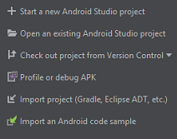Open Android Studio, popup will appear -

Click on Open an existing Android Studio project” and select the project (or)

Click **File** -> **Open**, Open file or Project window will appear, where you can select your project as follows:

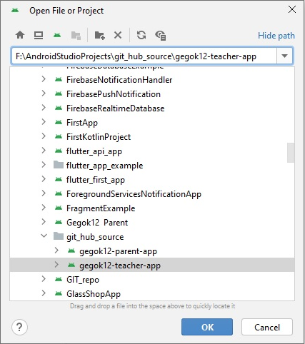

## ****2. Project configuration****

## Update the Package Name (Refactor)

## *****NOTE:***** *You must* *****change the package name FIRST*****before *adding google-services.json. If you add google-services.json first, the Firebase will cause build errors.*

### Steps:

1. In Android Studio:  
   **Right-click → gegosoft/yourappname → refactor → rename → rename package**
2. Change from:  
   com.gegosoft.yourappname
3. To your new desired package name.
4. Click **Do Refactor**.
5. Android Studio will rename all directories, manifests, Gradle namespaces, and references.

### After refactor:

* Check **build.gradle (app-level)** → namespace "com.xxx.xxx"
* Check **AndroidManifest.xml** → package="com.xxx.xxx"

✔ **Package name and Application ID must be identical.**

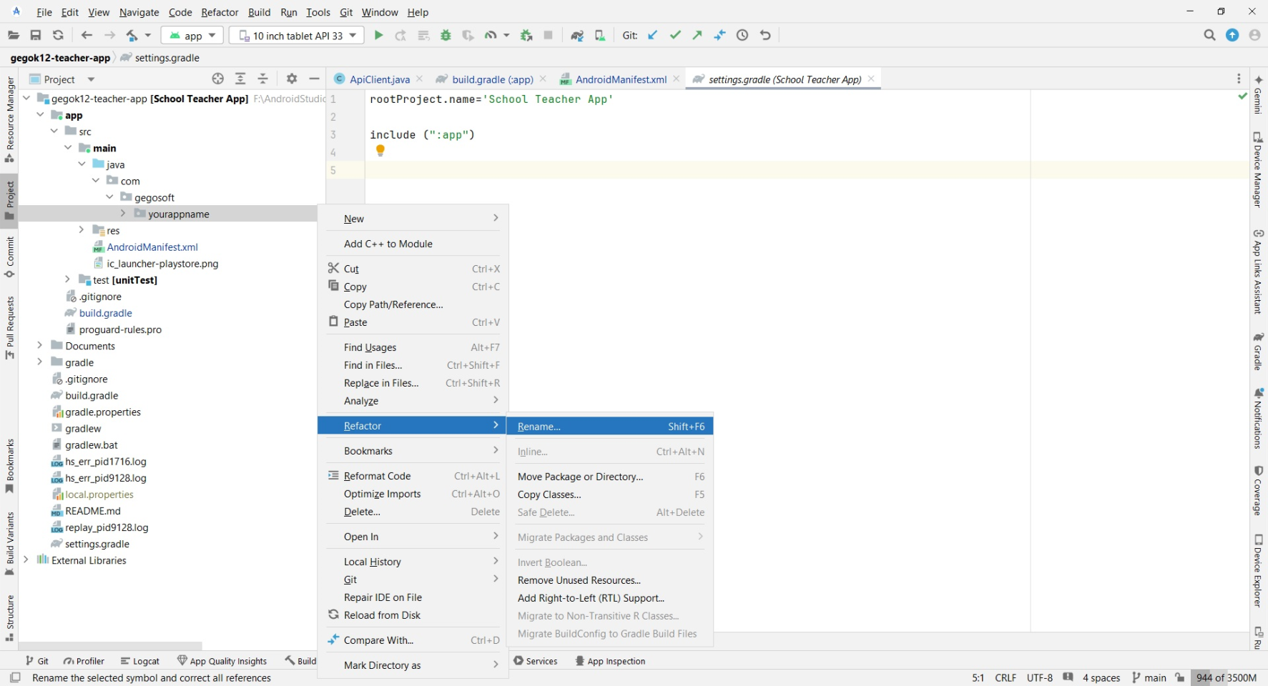

**If Package Name Not Updated Automatically,**After refactoring, check the following sections.

* **build.gradle (Module: app)**

Look for :

* + namespace "com.gegosoft.yourappname"
* applicationId "com.gegosoft.yourappname"

Replace with your new package name:

* + namespace "com.<your\_company>.<your\_app>"
* applicationId "com. .<your\_company>.<your\_app>"

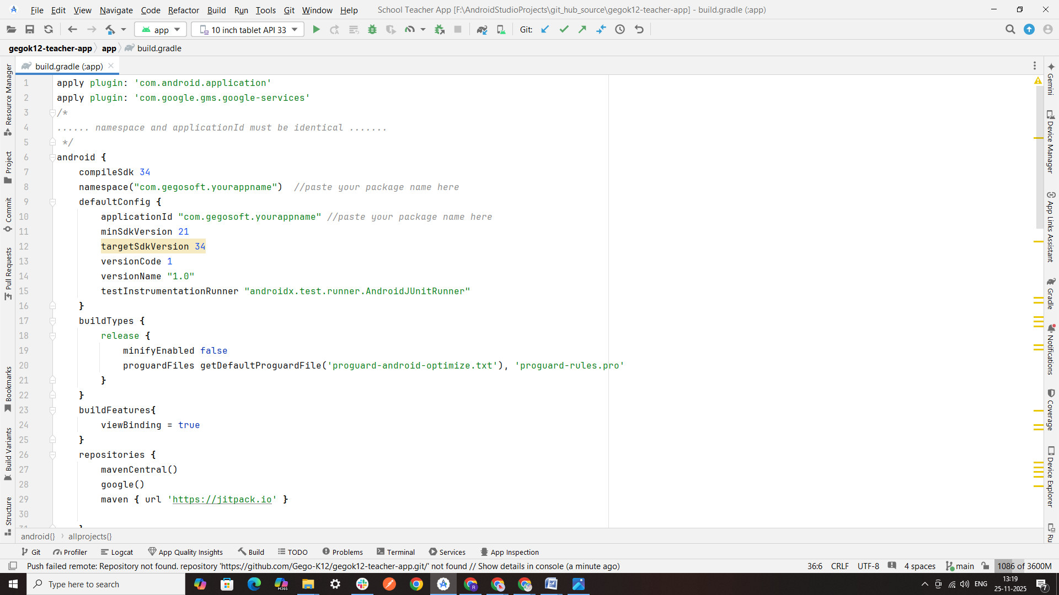

* **AndroidManifest.xml**

Open - app/src/main/AndroidManifest.xml   
Look for :

* + package="com.gegosoft.yourappname"

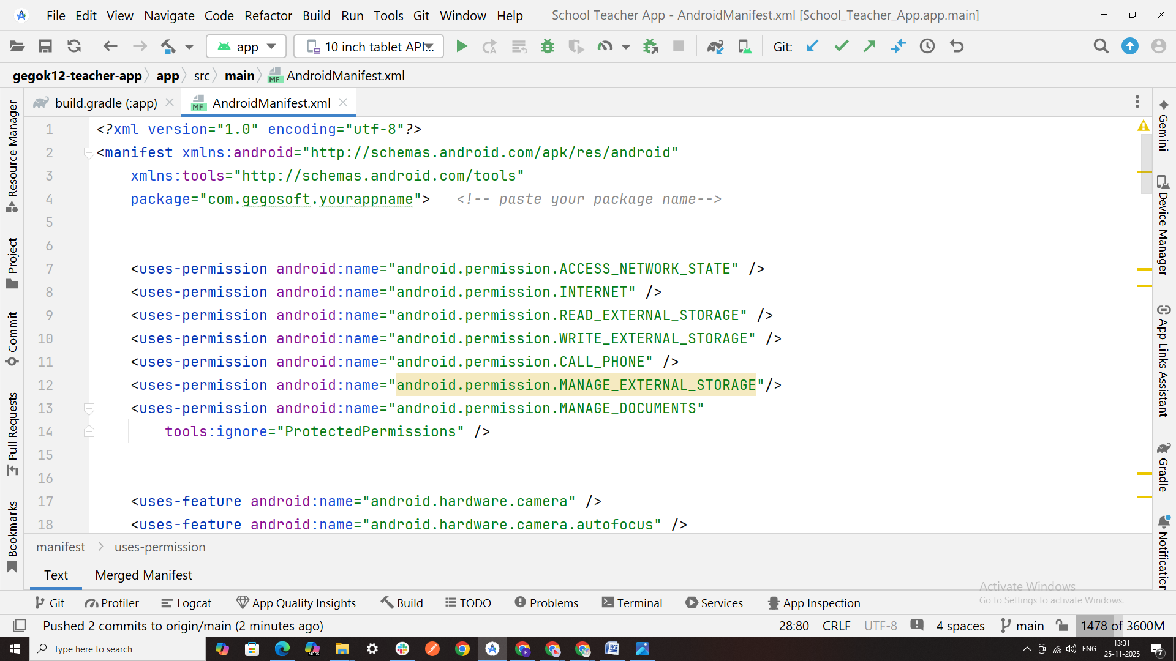

* **Check the Folder structure [** app/src/main/java/com/gegosoft/yourappname/ **]**
* If the folder names did not change automatically:  
  → Right-click the folder → Rename each level manually  
  (com → gegosoft → yourappname)

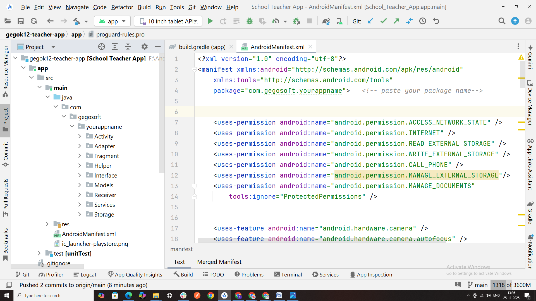

## Note: Add the google-services.json File (AFTER Package Rename)

## ****3. Firebase configuration****

* refer this link - <https://alphatech.technology/Blog-Entry-srk/Google-Services-Json-bek/> and get **google-services.json** from https://console.firebase.google.com/ and place it under app folder

project → app → google-services.json

* Reference JSON Structure [Please generate google-services.json with your package name]:

## Note: Please do not change or rename the google-services.json file. If a previous file exists, remove it and add the newly generated file from Firebase.

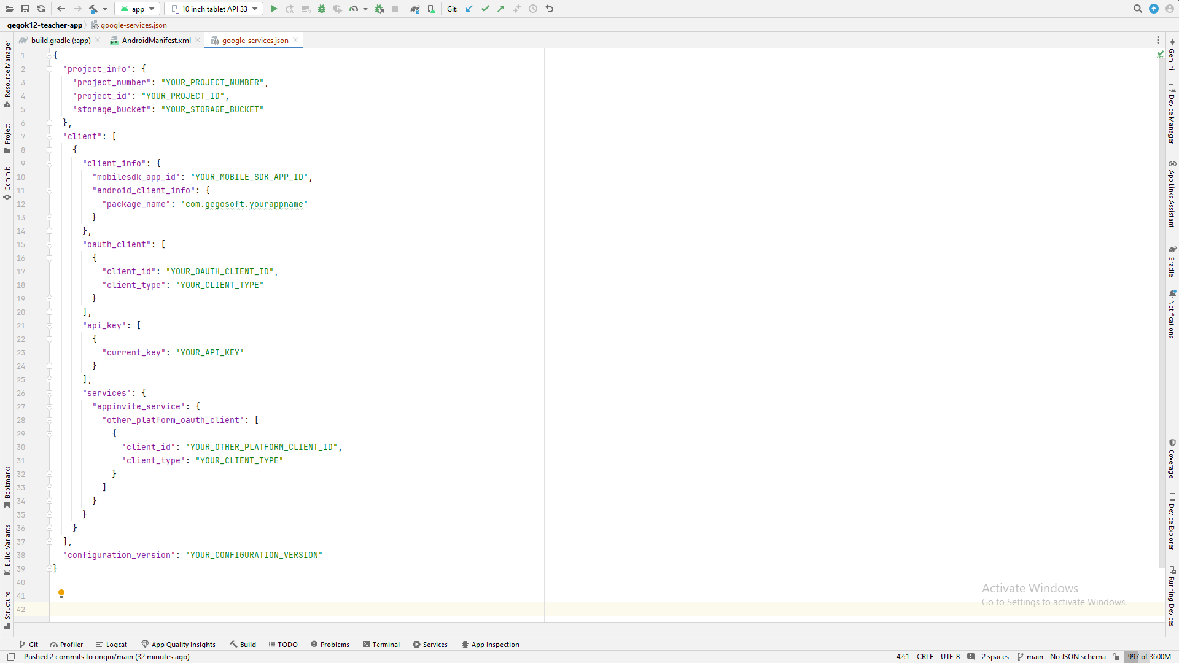

**4. Update Domain URL**

* Paste your domain URL in the ApiClient file [app\src\main\java\com\gegosoft\yourappname\Helper\ApiClient ]

**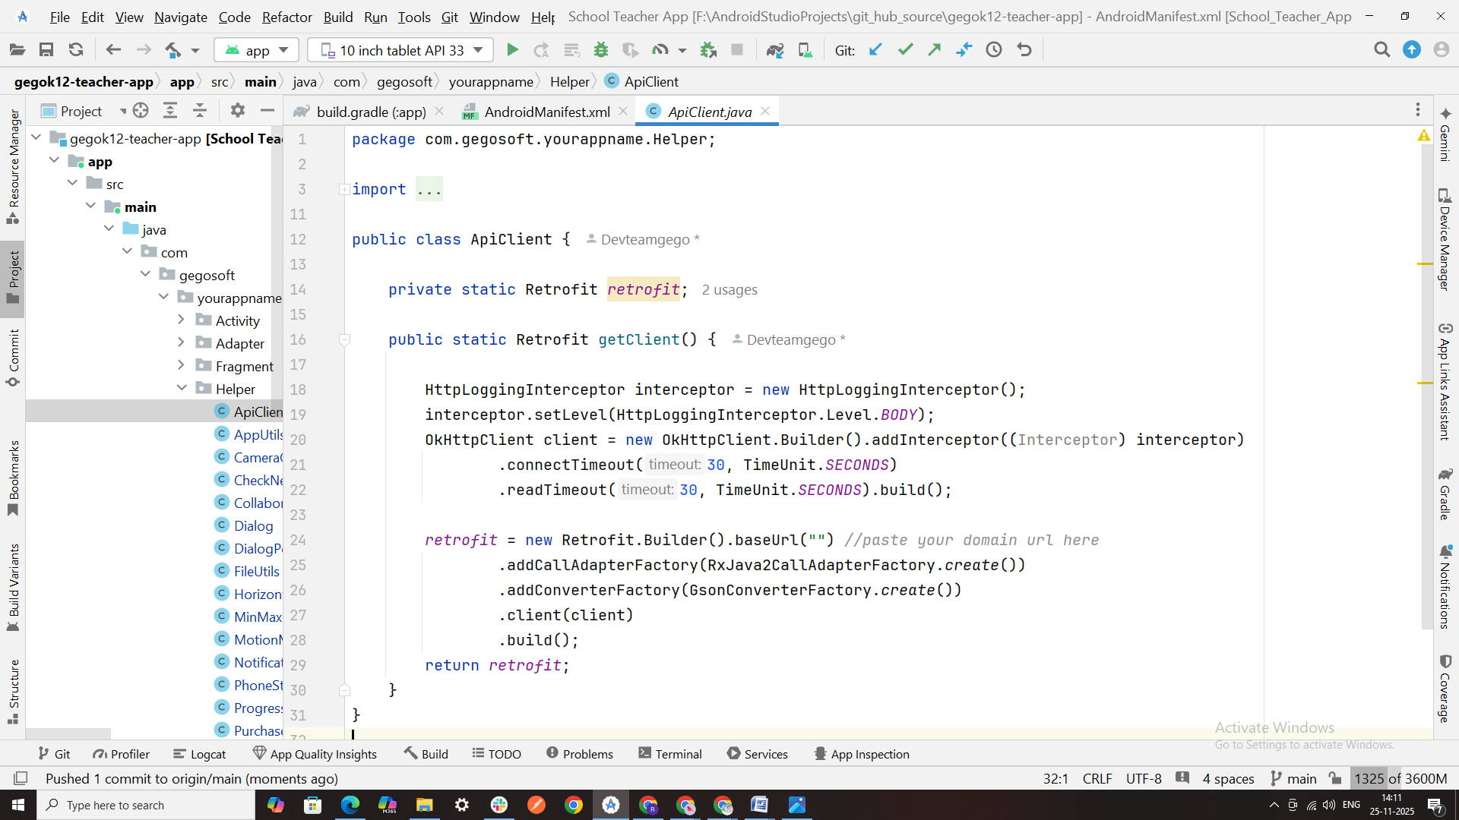**

# ****Confirm Everything Is Updated****

* The package name in code
* The folder directories
* The namespace and applicationId
* The manifest package attribute
* Your Firebase google-services.json package field
* Check domain url in ApiClient.java

**5. Sync the Project & Build**

* Click **Sync Now**
* Build and run the project

1. For creating virtual devices, from menu - select **Tools** -> **Device Manager** or you can select the icon given in the below image:

device_mngr_img.png

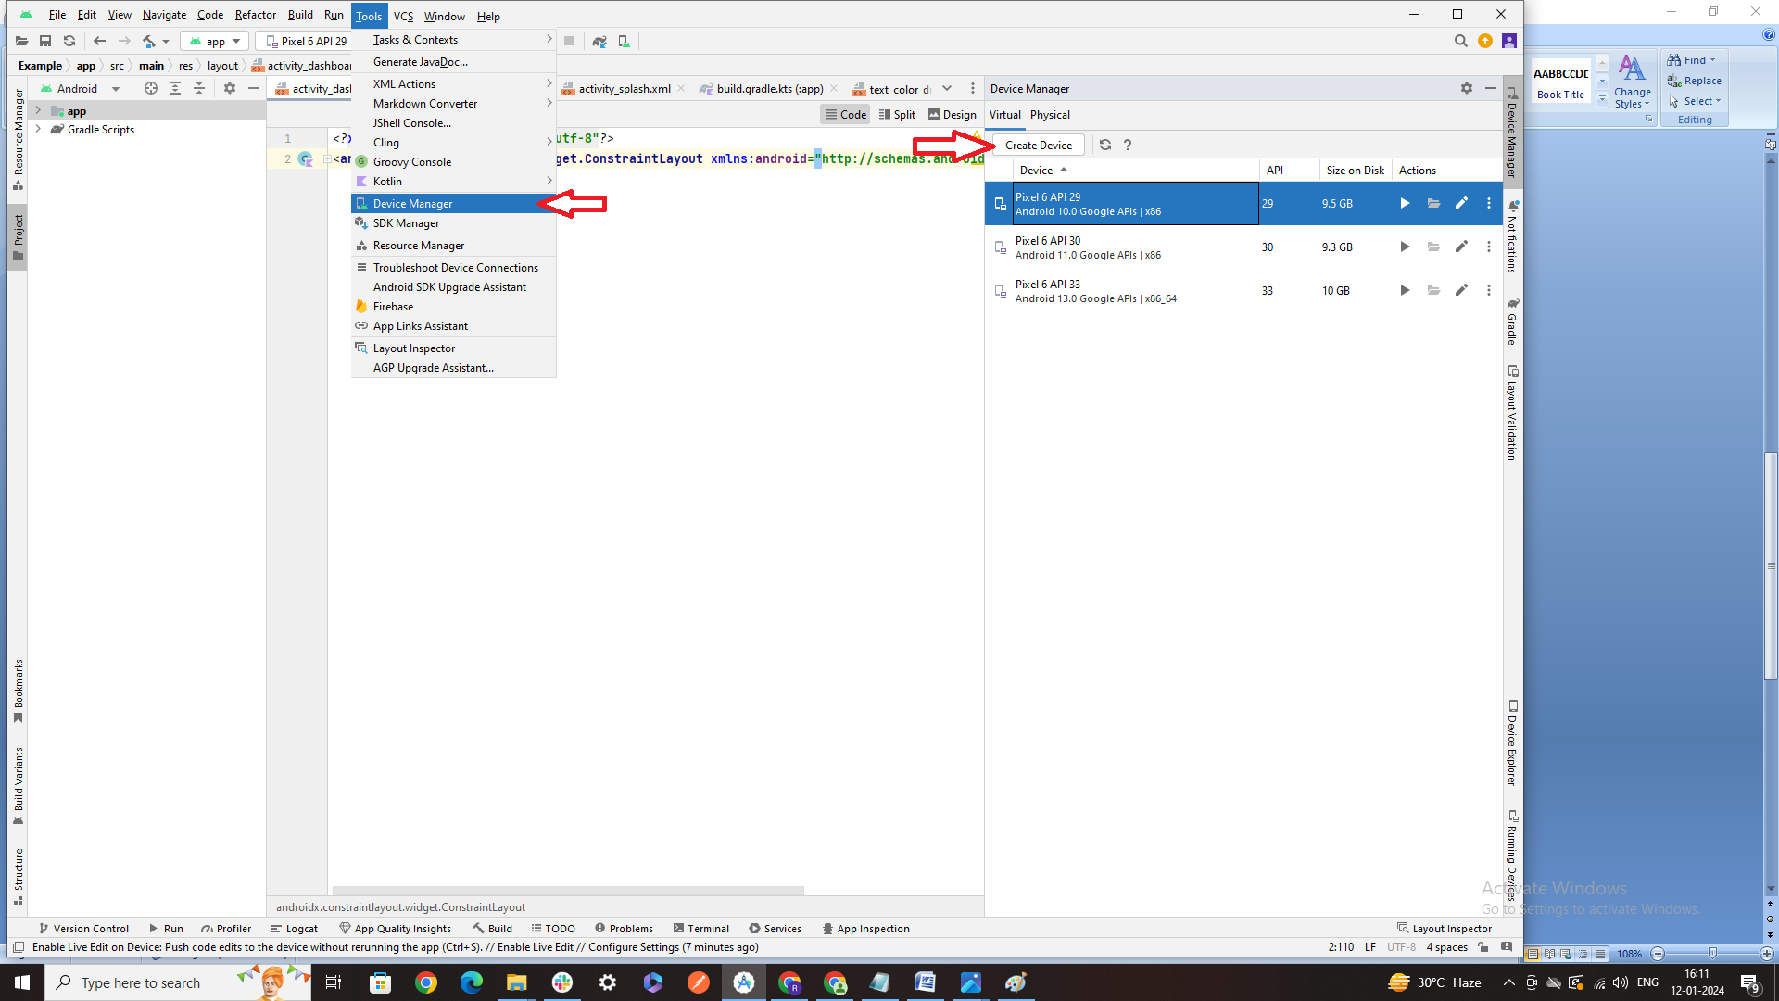

1. To run the project in emulator, from menu - select **Run** -> **Run ‘app’** or you can select the icon given in the below image:

run_img.png

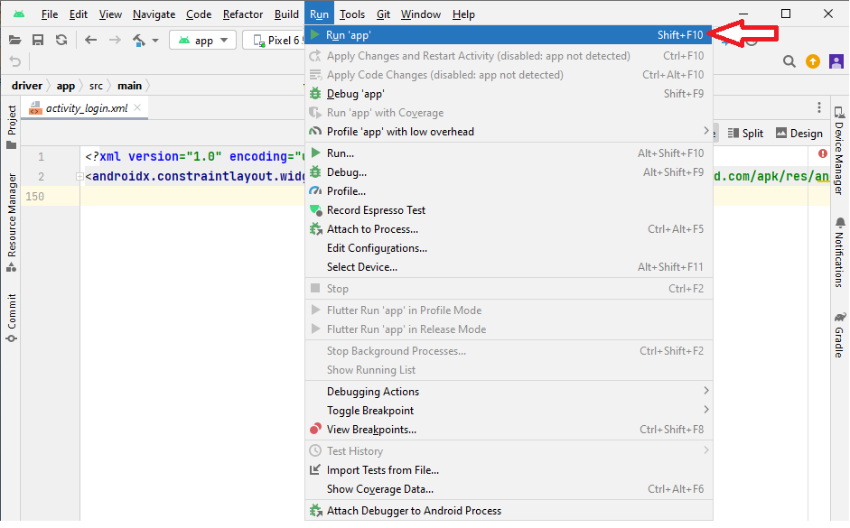

f) To build apk file (.apk), from menu - select **Build** -> **Build Bundle(s)/ APK(s)** -> **Build APK(s).** 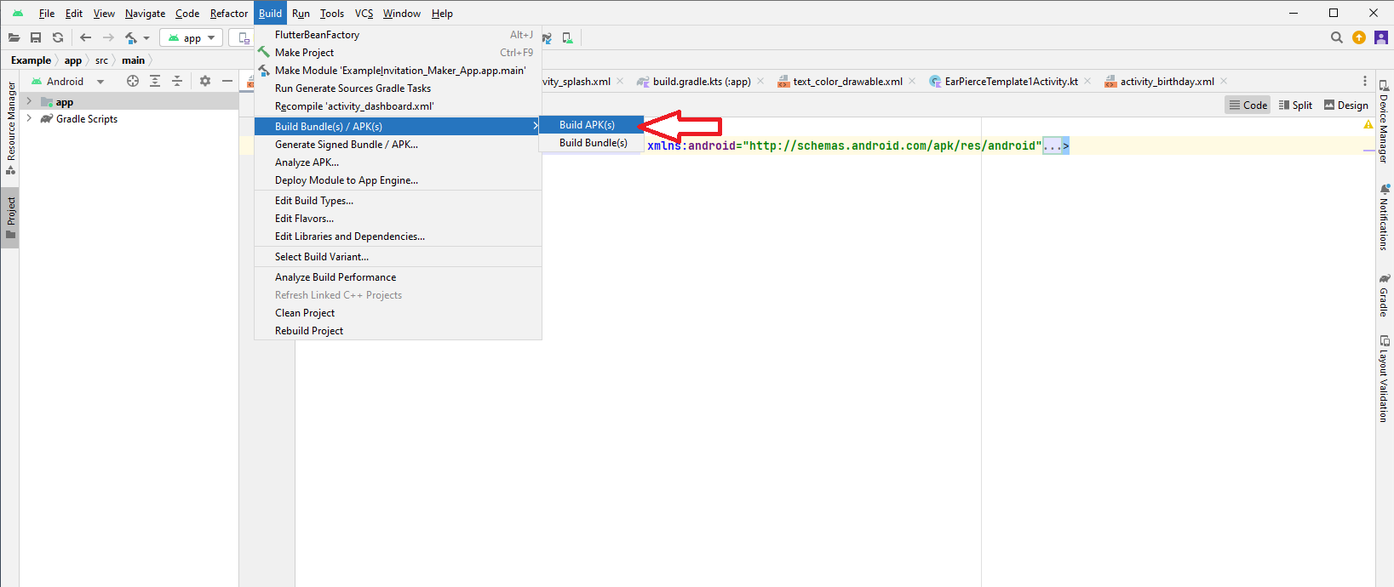

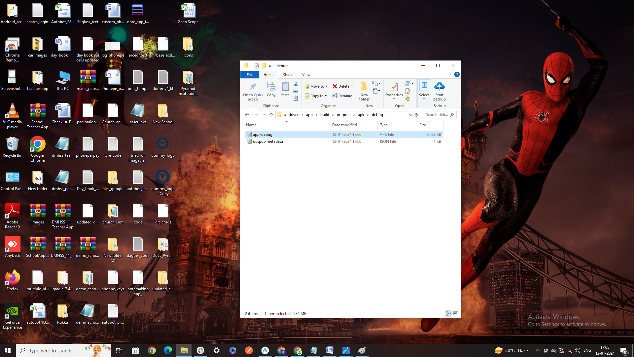g) At bottom right Build APK(s) popup will appear, click **locate** from the popup. It redirects to the folder, please click on **debug** folder , **app-debug** is the apk file, you can rename it by right-click on it.

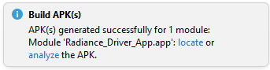

**Note:**

If you are getting Exception/Errors (like - Tag Mismatch! Or Build Failed):

* From menu select **Build** -> **Clean Project** and then, select **Build** -> **Rebuild** Project.
* From menu select **File** -> **Invalidate** **Caches** -> popup appears, check all the options [if any] and click “**Invalidate** **and** **Restart**” Button.